CHAPTER 8

How Many Satellites are Needed for a GPS Fix?

Introduction

In all our travels we now rely on SatNav. The GPS system (Global Positioning System – and this is another one of those acronyms where we tend to repeat the word System, like ATM machine) first appeared in the 1990s. It was a boon for amateur sailors who could safely navigate in any weather. I bought a Garmin GPS38 (fig. 1) in 1996 when visiting friends in Houston. It blew my mind. There were 24 satellites in use at the time but now, in 2023 there are 31 operational satellites. But about 50 other satellites have been launched and retired from service. Maybe we need another chapter on space junk …

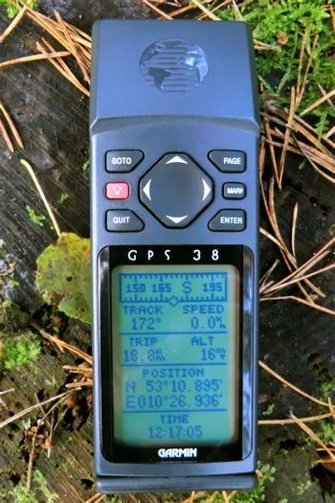

Fig. 1. A Garmin GPS38, purchased in 1996. I wonder if it still works?
[OUP - copyrighted image. ] HUGH HAS ONE, CAN TAKE A PHOTO OF IT

The full answer to the question of how many satellites are needed varies according to the circumstances. The GPS system works by measuring the time taken for signals from several satellites, whose positions are known, to arrive at the GPS receiver. The satellites are at a height of about 20,000 km above the surface of the earth, or approximately three earth radii, with each taking about twelve hours to orbit the earth. There are 24 GPS satellites in use globally and are arranged so that at least four are always available relative to any one fixed position on earth. Fig. 2 shows two of these satellites.

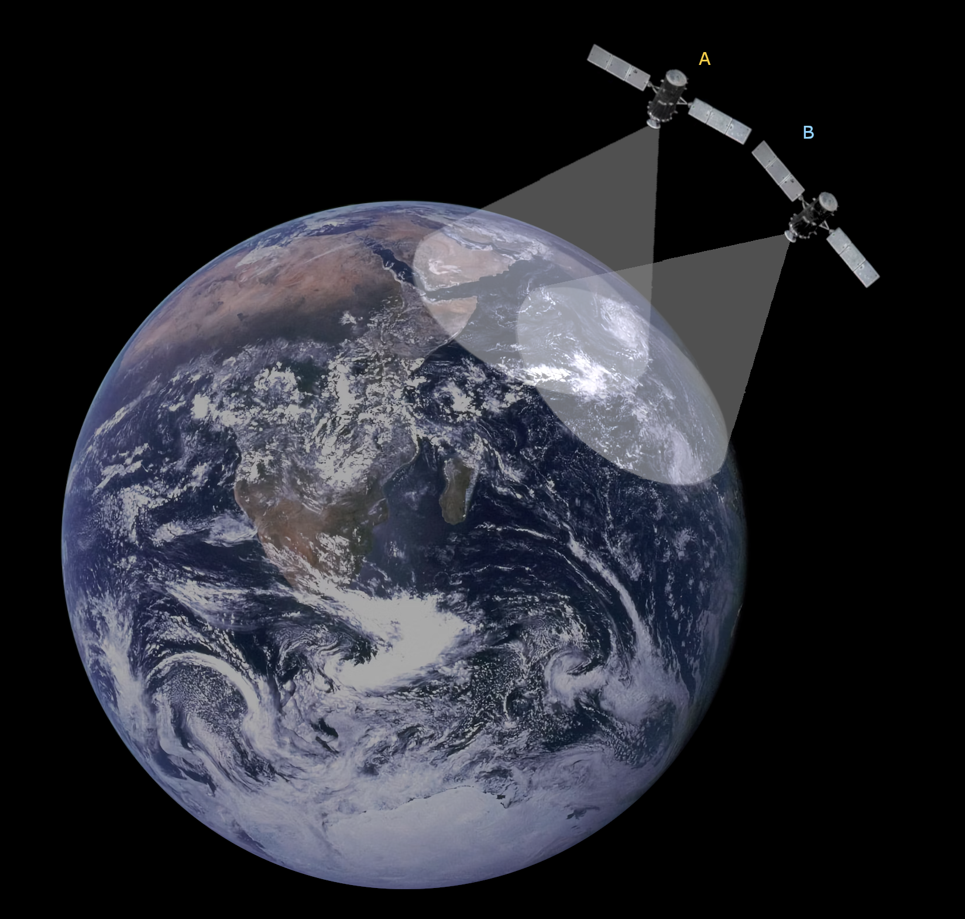

Fig. 2. Two satellites A and B. Circles are shown on the surface of the Earth, the perimeters of which have equal signal arrival times from each of the satellites.
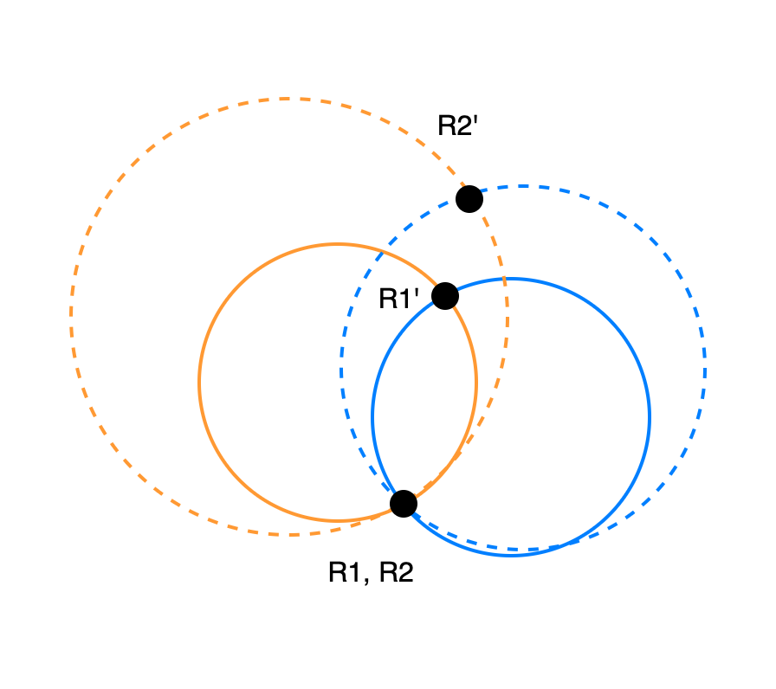
Fig. 3. The projection of the circles from satellites A (orange) and B (blue) at two times T1 (solid) and T2 (dashed). The signal at T1 alone fixes the receiver at either R1 or R1’. An additional satellite fix is required to remove the ambiguity. Alternatively, the signal at T2 can be used provided that the receiver is known not to have moved any appreciable distance. In choosing between R2 and R2’, R2 makes better sense.

Lines of equal time difference for the signal to travel are represented by circles on the surface of the earth with the centre of the circle directly below the satellite. These circles intersect at two receiver points R1 and R1’ so that a single measurement of position is ambiguous. A third satellite is needed, therefore, to avoid this ambiguity, but there is a cheaper way. The centres of each circle moves at almost 1000 m/s (a useful rough conversion from mph to m/s is to divide by two) since they circle the earth in twelve hours. Hence, even if the two points are very close together, which might occur by chance if the receiver and satellites were in the same plane, a minute later one of the receiver points (R1’) will have moved 60 km to R2’, while the other, receiver point R1, will be in much the same place (we assume it is not in a fighter jet), as shown in Fig. 3. Therefore, we can use two readings separated by a short time interval to resolve the ambiguity. If the receiver has an accurate clock synchronised to the satellites and we know its height above sea level so that there are only two co-ordinates to determine, then two satellites are enough to determine the terrestrial position. This might apply, for example, to an aircraft carrier on the ocean.

A third satellite is required to determine the position the height is unknown. There is still an ambiguity, since there are two possible points, but the height is much less variable than the distance on the ground, so the second point is likely to put the aircraft carrier 60 km in the air, or under the ground, as well as travelling at more than 2000 miles an hour. (The Japanese for ‘too many cooks spoil the broth is’ ‘too many captains put the ship up a mountain’).

For most users the cost of an atomic clock, which is needed to keep synchronism with the satellite clocks, is prohibitive, so a fourth satellite is needed to determine the error in the local clock. Assuming this error to be δ, we need to find the solution to the following four equations;

with n = 1-4.

Here the four unknowns are (x,y,z), the co-ordinates of the receiver and δ. δ is the error in the receiver clock. x_{n} etc. represent the co-ordinates of the n^{th} satellite and t_{n} is the correct time the signal takes to arrive from the n^{th} satellite. This is a simple numerical calculation for any computer and completes the practical requirements of the problem. However, it is of interest to see whether the addition of the fourth satellite also removes the ambiguity in a single measurement. It is easy to see from the geometry (Fig. 2) why there are two solutions if the receiver clock is accurate. To prove the number of solutions that exist are for eqn 1.11 requires a mathematician with considerably more skill and patience than I possess! The question can be answered mostly, however, with a numerical example. We take three satellites above a horizontal plane, with an unknown error in the receiver clock and assume reasonable positions for the satellites. The three equations can be solved numerically with various initial guesses for the unknowns and only two solutions were found, as shown in Fig. 4. The circles for each satellite have the same colour and are concentric. The radii depends on the solution for x, y and δ. The continuous lines are one solution and the dashed the other.

Sol.2
Sol.1
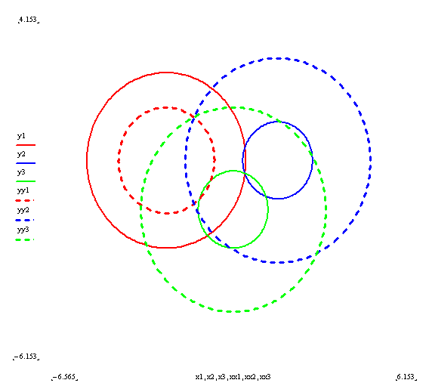
Fig. 4. A solution on a plane for three satellites. The three solid circles show constant arrival times for three satellites. Two solutions are possible.

We can conclude that if we use the fourth satellite (in a 3D problem) to correct the local clock it cannot also be used to remove the ambiguity, since two solutions still remain. However, as pointed out at the beginning , one of these solutions is easily excluded by its high speed. Well at least it works for us terrestrial users. Modern GPS receivers get a fix on maybe 12 satellites so a lot of this clever working out is no longer needed.

